

THE UNIVERSITY OF

LUCKNOW

REPORT OF MINOR PROJECT

ON

**“RESTAURANT MANAGEMENT SYSTEM”**

Partial Fulfilment of the Requirement for the Award of the degree of

**BACHELOR OF COMPUTER APPLICATION**

**By**

**ASHUTOSH PRASAD (180920580015)**

**AMAN RATHORE (180920580007)**

**Under the Supervision of**

**DR. S.A.A Rizvi**



(Department of BCA)

**SCHOOL OF MANAGEMENT SCIENCES LUCKNOW**

(Affiliated to Lucknow University 2017-2020)

**CERTIFICATE**

This is to certified that ***Mr. Ashutosh Prasad*** and ***Aman Rathore*** has successfully completed ***Project Based Summer Internship*** in ***Python Programming Language*** from June 12th 2019 to August 2th2019conducted at ***Lucknow Learning Centre Of Centre Of MTA India*** and has been awarded the grade A+ on August 10th 2019.

During this period of Project Based Internships they were found innovative, punctual hardworking and inquisitive.

### **Dr. S.A.A RIZVI**

### Co-Ordinator



**Dr.S.A. A RIZVI Aman Rathore**

***(Coordinator)***

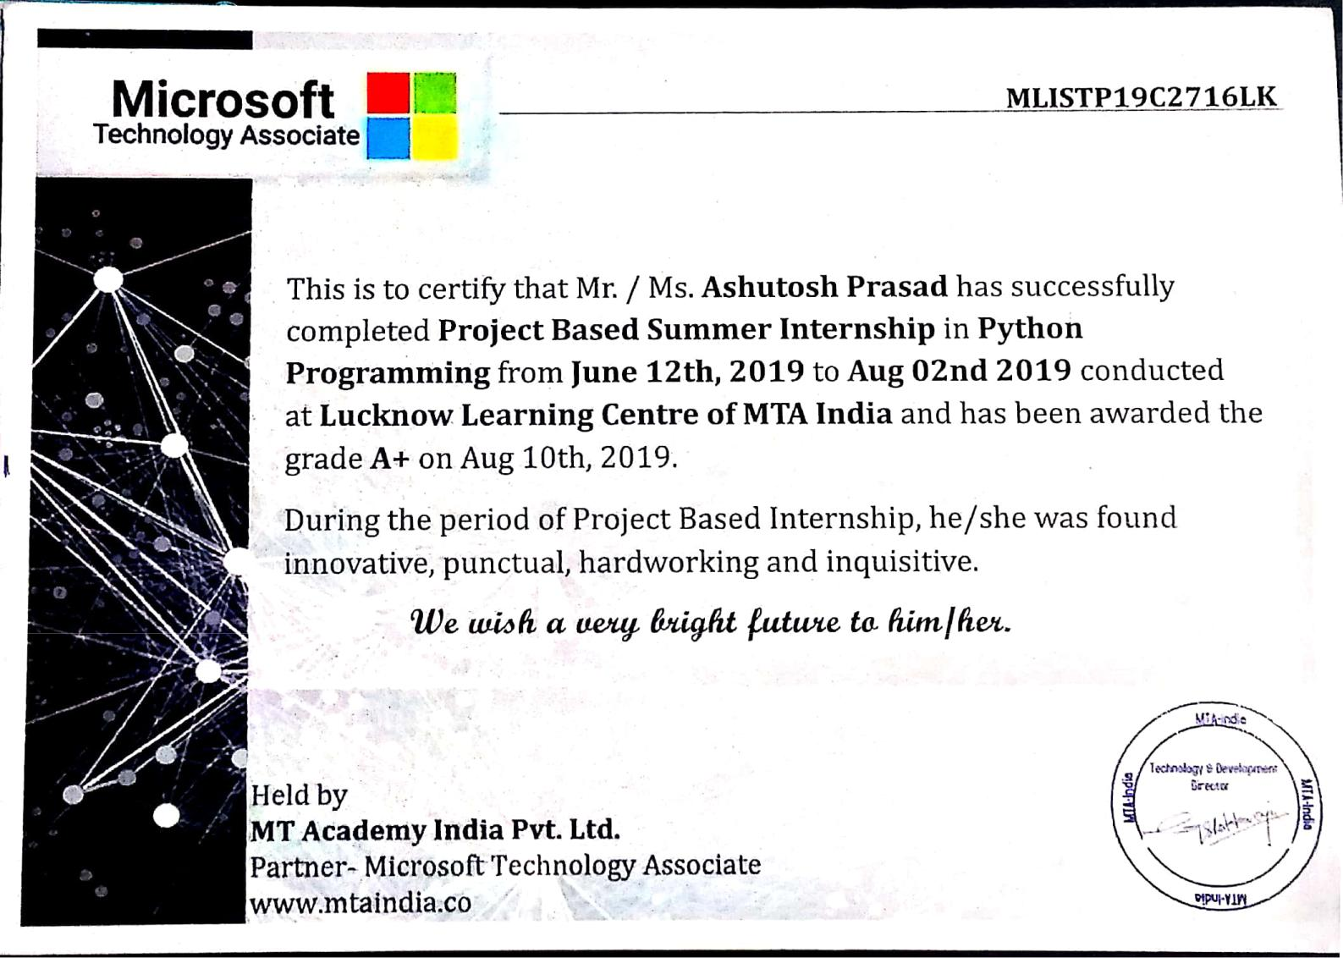

**Dr.S.A. A RIZVI Ashutosh Prasad**

***(Coordinator)***

**DECLARATION**

I hereby declare that this submission is my own work and that, to the best of my knowledge and belief, it contains no material previously published or written by another person nor material which to a substantial extent has been accepted for the award of any degree or diploma of the university or other institute of higher learning, except where the acknowledgement has been made in the text.

**ASHUTOSH PRASAD**

**AMAN RATHORE**

**CONTENTS**

* **Introduction**
* **What is PYTHON**
* **Why we use PYTHON**
* **Downloading and Installation of python**
* **Model**
* **Feasibility Study**
* **System Testing**
* **Overview & Review of Output and Input of Project**

**INTRODUCTION**

In the fast changing world information technology and information management are going to play an important role. We are living in the computer age during past some year. The Computer its way into almost every aspects of human life and living. A computer is admirably suited to handle any information and hence is an information processor that is, it can receive data, perform some basic operation data and produces results according to a predetermined program.

This is designed especially for a restaurant which wants to attend their customers in a very well manner. This system has the capability to take the orders from the customers.

This proposed website is managing all the crimes and criminal records.

**Objectives**

Python Projects is combine with different modules identified with various source code. It’s include Planning, designing and execution. Python Projects for beginners is ideal on the off chance that it fulfills the client necessity. It's taking less time during the execution and its work smoothly. Objective of a Python Project is Smarter, attractive, innovative, and easy to use, Python is easy to develop even a user can also make small changes and modification. With the help of Python, we can develop best web application with minimum source code.

It is used for:

* web development (server-side),
* software development,
* mathematics,
* system scripting

The aim of Python Project is to develop dynamic and appealing web and desktop application according to client requirement. Python Project is most requesting in current corporate market because it increasingly attractive, faster and have best look and feel.

**Advantages of Python**

Today, Python is widely used and most demandable scripting language on the web. Python is a very popular scripting language which is specially designed for skilled website development as well as desktop application. Python programming language is the most preferred programming language that is suited for website development as well as desktop application making can be easily done.

* Python works on different platforms (Windows, Mac, Linux, Raspberry Pi, etc.).
* Python has a simple syntax similar to the English language.
* Python has syntax that allows developers to write programs with fewer lines than some other programming languages.
* Python runs on an interpreter system, meaning that code can be executed as soon as it is written. This means that prototyping can be very quick.
* Python can be treated in a procedural way, an object-orientated way or a functional way.

### **Good to know**

* The most recent major version of Python is Python 3, which we shall be using in this tutorial. However, Python 2, although not being updated with anything other than security updates, is still quite popular.
* In this tutorial Python will be written in a text editor. It is possible to write Python in an Integrated Development Environment, such as Thonny, Pycharm, NetBeans or Eclipse which are particularly useful when managing larger collections of Python files.

**What is Python?**

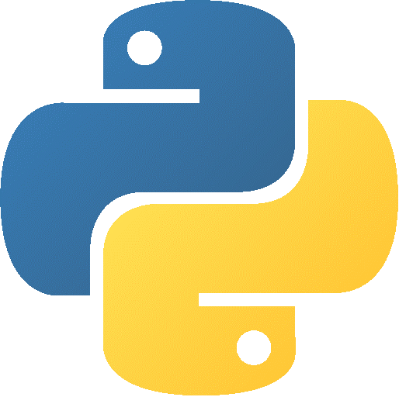

Python is a popular programming language. It was created by Guido van Rossum, and released in 1991. Python is a widely used general-purpose, high level programming language. It was initially designed by Guido van Rossum in 1991 and developed by Python Software Foundation. It was mainly developed for emphasis on code readability, and its syntax allows programmers to express concepts in fewer lines of code.

Python is a programming language that lets you work quickly and integrate systems more efficiently.

**Beginning with Python programming:**

* 1. **Finding an Interpreter:**

Before we start Python programming, we need to have an interpreter to interpret and run our programs. There are certain online interpreters like, http://ideone.com/ or http://codepad.org/ that can be used to start Python without installing an interpreter.

***Windows*:** There are many interpreters available freely to run Python scripts like IDLE ( Integrated Development Environment ) which is installed when you install the python software from [**http://python.org/**](http://python.org/)

**Why We Use PYTHON?**

The people who love doing programming loves to learn more and more languages. As the use of the internet is increasing, programmers like to develop more online applications.

Machine Learning is the hottest trend in modern times. According to FOREBS, Machine learning patents grew at a **34%** rate between 2013 and 2017 and this is only set to increase in the future. And **Python**s the primary programming language used for much of the research and development in **Machine Learning.** So much so that Python is the top programming language for Machine Learning according to GitHub. However, while it is clear that Python is the most popular, this article focuses on the all-important question of **“Why is Python the Best-Suited Programming Language for Machine Learning?”**

**Simple and easy to learn**

One of the easiest languages for building desktop, web application is Python scripting language, which allows developers to quickly grasp on application development. Python is very similar to C and Java therefore if a developer knows how to write code in C and Java, they can quickly learn python scripting language too.

**Speed**

It is much faster than any other scripting language because it does not require a lot of system’s resources. Even running with other software without getting slow and making other processes slow. An application made on Python programming language is much easy to get hosted and more supportive.

**Free and Open Source**

Python is Free, there is not any kind of pricing using Python programming language nor with its documentation nor with scripting language itself. And now it is more clear that best programming language for web application development is Python

**Object Oriented Language**

OOP, is the concept that gives you all advantages nowadays. From reducing the line of codes to the reuse of classes, all are the features that every developer wants to use while developing the application.

PHP provides you this advantage of reusing other language classes that are written in either Java or Windows COM objects, you can call them. Creating custom classes is the main advantage for Python developers. A custom class is a class that other classes can borrow so, it extends the capabilities of Packages even more.

**Python Programming Benefits For Business**

Python programming language is an impressive choice for fast prototyping and development of both static and dynamic web apps. Startup businesses, advertising agencies, and media agencies, as well as miniscule software organizations, are the most popular sectors where Python programming is used.

**Downloading and Installation of python**

The Python download requires about 25 Mb of disk space; keep it on your machine, in case you need to re-install Python. When installed, Python requires about an additional 90 Mb of disk space.

### **Downloading**

1. Click [Python Download](https://www.python.org/downloads/).

The following page will appear in your browser.

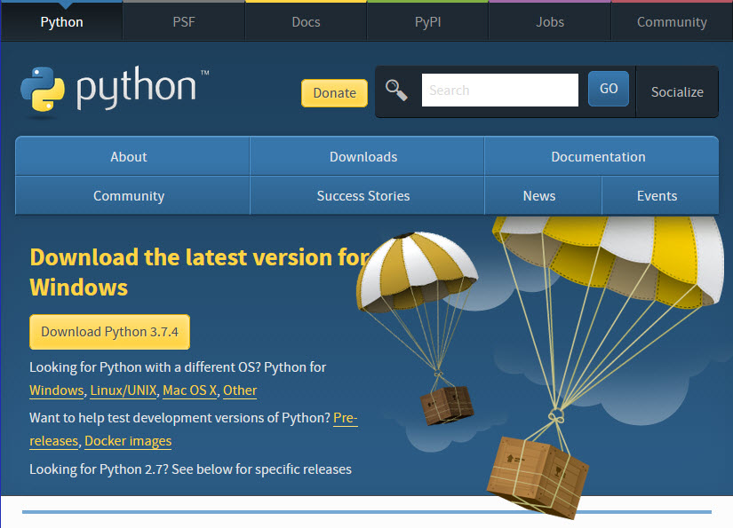

1. Click the **Windows** link (two lines below the **Download Python 3.7.4** button). The following page will appear in your browser.

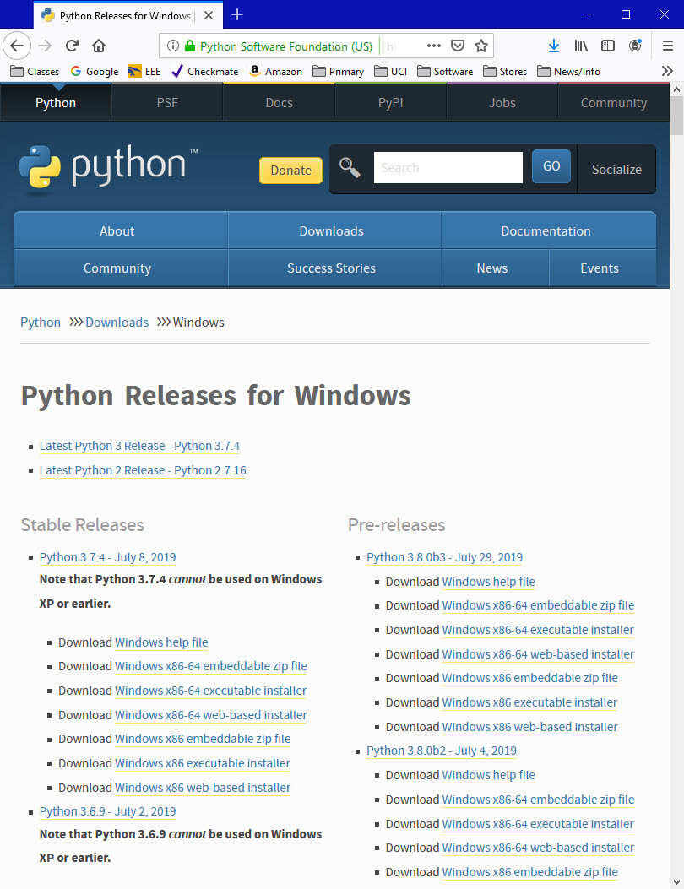

1. Click on the **Download Windows x86-64 executable installer** link under the top-left **Stable Releases**.

The following pop-up window titled **Opening python-3.74-amd64.exe** will appear.

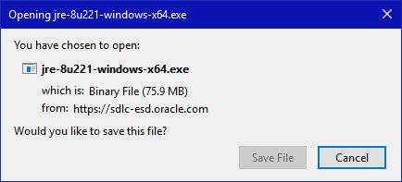

Click the **Save File** button.

The file named **python-3.7.4-amd64.exe** should start downloading into your standard download folder. This file is about 30 Mb so it might take a while to download fully if you are on a slow internet connection (it took me about 10 seconds over a cable modem).

The file should appear as

https://www.ics.uci.edu/~pattis/common/handouts/pythoneclipsejava/images/python/exefile.jpg

1. Move this file to a more permanent location, so that you can install Python (and reinstall it easily later, if necessary).
2. Feel free to explore this webpage further; if you want to just continue the installation, you can terminate the tab browsing this webpage.
3. Start the **Installing** instructions directly below.

### **Installing**

1. Double-click the icon labelling the file **python-3.7.4-amd64.exe**.

A **Python 3.7.4 (64-bit) Setup** pop-up window will appear.

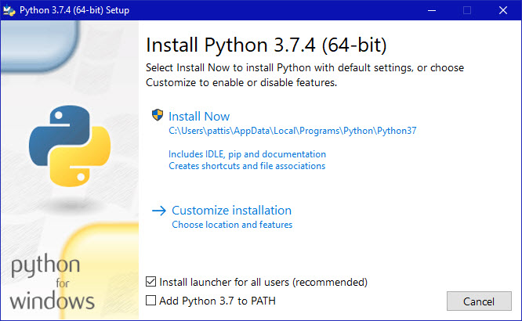

Ensure that the **Install launcher for all users (recommended)** and the **Add Python 3.7 to PATH** checkboxes at the bottom are checked.

If the Python Installer finds an earlier version of Python installed on your computer, the **Install Now** message may instead appear as **Upgrade Now** (and the checkboxes will not appear).

1. Highlight the **Install Now** (or **Upgrade Now**) message, and then click it.

When run, a **User Account Control** pop-up window may appear on your screen. I could not capture its image, but it asks, **Do you want to allow this app to make changes to your device**.

1. Click the **Yes** button.

A new **Python 3.7.4 (64-bit) Setup** pop-up window will appear with a **Setup Progress** message and a progress bar.

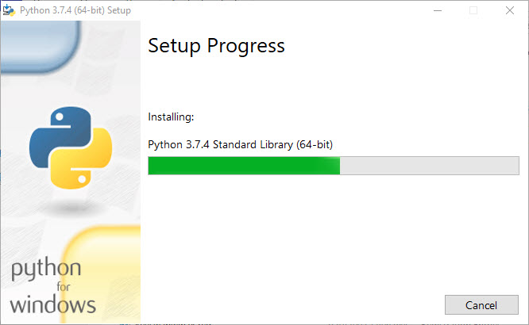

During installation, it will show the various components it is installing and move the progress bar towards completion. Soon, a new **Python 3.7.4 (64-bit) Setup** pop-up window will appear with a **Setup was successfully** message.

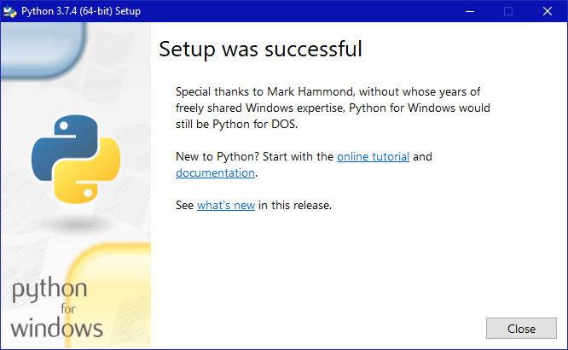

1. Click the **Close** button.

Python should now be installed.

### **Verifying**

To try to verify installation,

1. Navigate to the directory **C:\Users\Pattis\AppData\Local\Programs\Python\Python37** (or to whatever directory Python was installed: see the pop-up window for Installing step 3).
2. Double-click the icon/file **python.exe**.

The following pop-up window will appear.

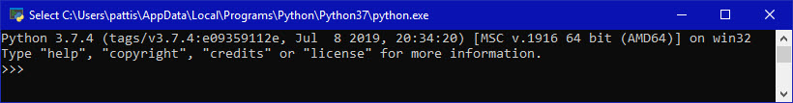

A pop-up window with the title **C:\Users\Pattis\AppData\Local\Programs\Python\Python37\python.exe** appears, and inside the window; on the first line is the text **Python 3.7.4 ...** (notice that it should also say 64 bit). Inside the window, at the bottom left, is the prompt **>>>**: type **exit()** to this prompt and press **enter** to terminate Python.

You should keep the file **python-3.7.4.exe** somewhere on your computer in case you need to reinstall Python (not likely necessary).

**Installing of Vscode**

## Introduction to VS Code

Visual Studio Code (VS Code) is a source code editor developed by Microsoft that can run on Windows, macOS, and Linux. It is free, open-source, and is embedded with debugging tools, integrated terminals, built-in Git version control, code navigation, refactoring, and so on.

In addition to the built-in features, VS Code is highly customizable as users can install extensions to add additional support for languages, themes, and debuggers – among others.

Although VS Code comes with built-in support for JavaScript, Typescript, and Node.js, it has a vibrant ecosystem of extensions for other languages including Python.

In this article, we’ll explore the vibrant support VS Code provides to make editing source code simpler for Python developers. We will walk through installing, browsing and adding extensions, as well as other useful packages to help with the Python development.

### ***Step-1: Downloading VS-Code Installer?***

1) Navigate to download link [***https://code.visualstudio.com/download***](https://code.visualstudio.com/download)  
You can choose the custom 32 bit or 64 bit if you are aware of which architecture system you are using. If you are not sure then you can simply ***click on windows Icon***. This would download the VS Code installer to your machine.

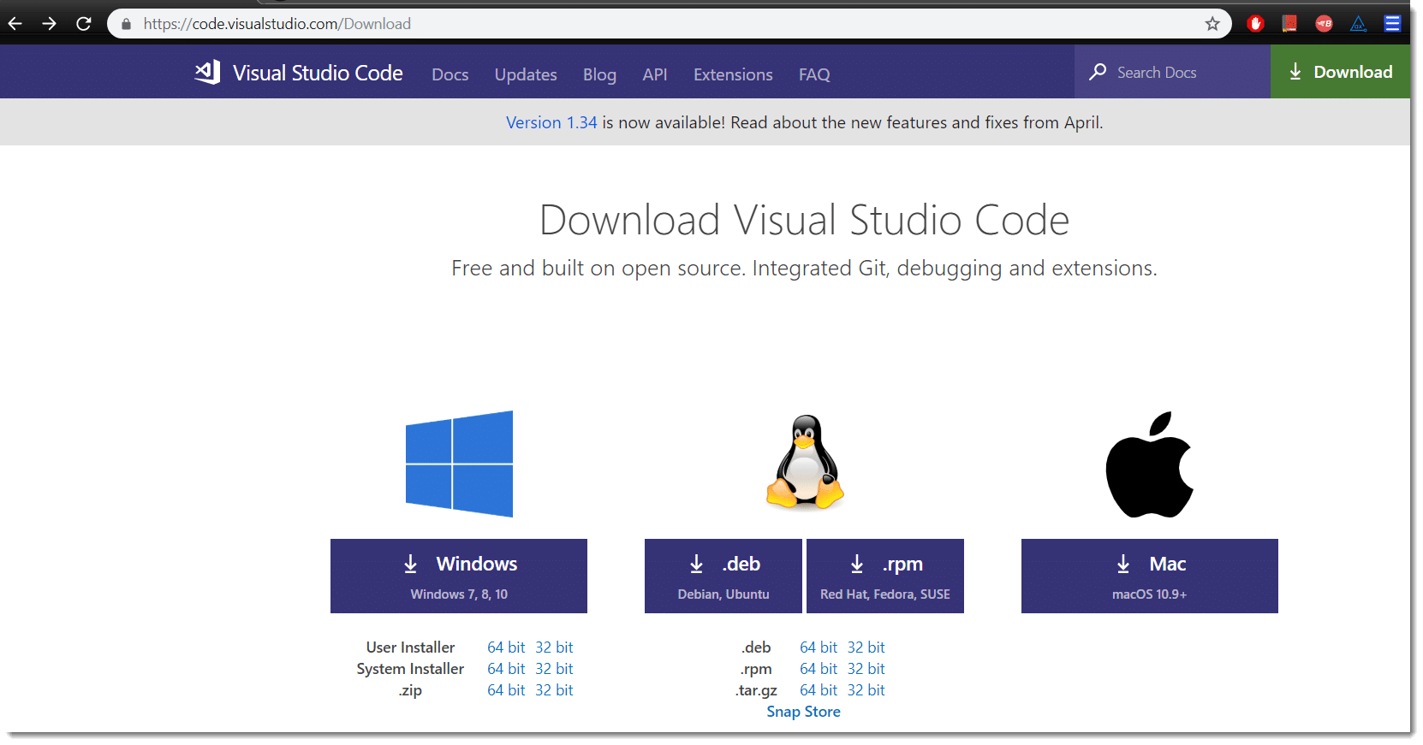

Once the installer is downloaded, proceed with the installation.

### ***Step 2: Installing Visual Studio Code***

***1) Start VS-Code Installation Process:***Navigate to the folder where ***VS-Code Installer*** is downloaded and ***double click*** on it to kick start the installation process. Once the installation is started, click ***Next*** on the welcome screen.

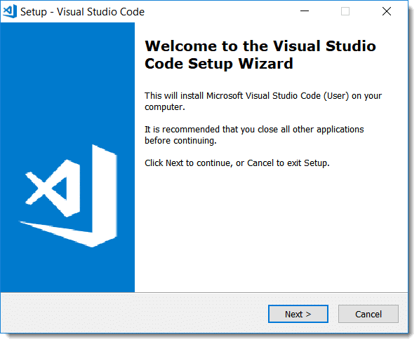

***2)Accept the License Agreement:***Go through the license agreement, Click on I accept the agreement and click ***Next***

. 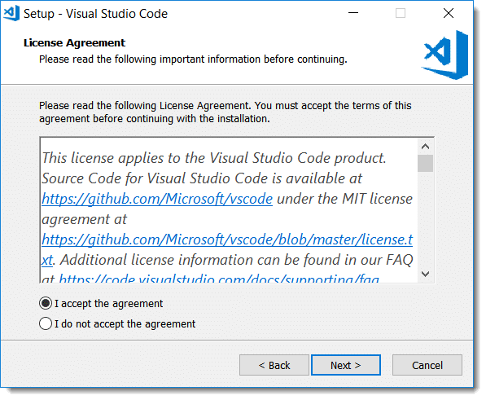

***3) Choose Installation Directory:***By default, VS-Code is installed under C:\users\{username}\AppData\Local\Programs\Microsoft VS Code, but this default location of installation can be changed by clicking on Browse.

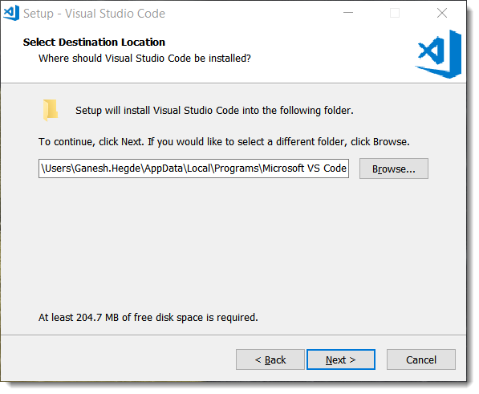

***4) Choose Start Menu Folder:***By Default, the program’s shortcut will be placed in the Visual Studio Code folder but this can be changed from this window. Once done, click on **Next.**

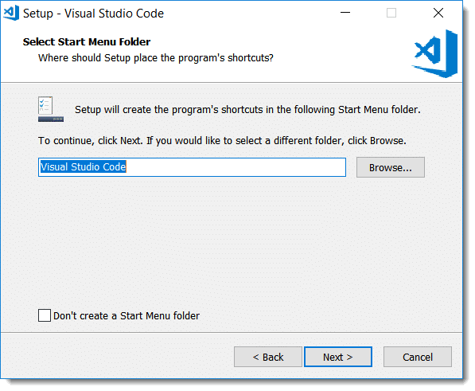

**5) Choose Additional Options:**Various options to choose:

1. **Create a desktop icon**: Upon choosing this option desktop shortcut will be created, it will be easy for you to launch VS Code next time.
2. **Add “Open with code” action to Windows Explorer file context menu**: This would allow an option to open a file in VS Code on performing the right click on the file.
3. **Add Open with code action to Windows Explorer folder context menu**: This would allow an option to open a folder in VS Code on performing the right click on the folder.
4. **Register Code as an editor for supported file types**: File supported by VS Code will be automatically opened in Visual Studio Code editor.
5. **Add to PATH (available after restart)**: Visual Studio Code installed directory path will be added to an environment variable automatically but after the restart.

Once you choose options that you need, click on **Next**to continue the installation:

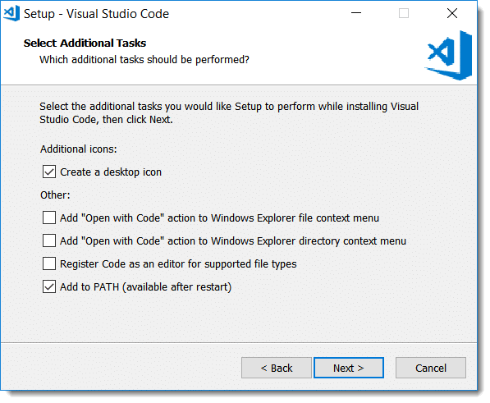

***6) Review selected options:***Ready to Install screen will show you things which you chose from the previous screen, you can review. Change anything if necessary, else click on ***Install*** to begin the installation.

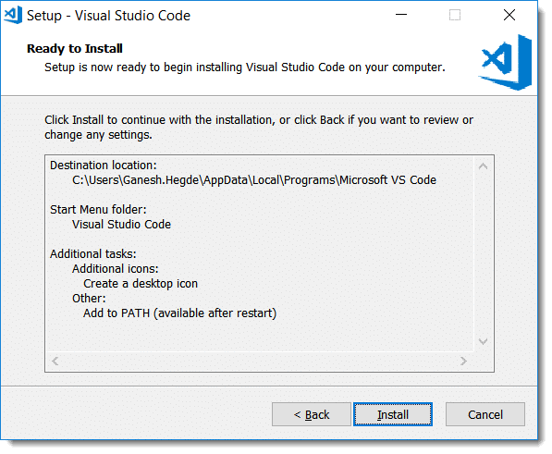

***7) Launch the Visual Studio Code:***Wait for the installation to complete and at the end final window will be displayed. Select ***Launch VS Code*** and click on ***Finish***.

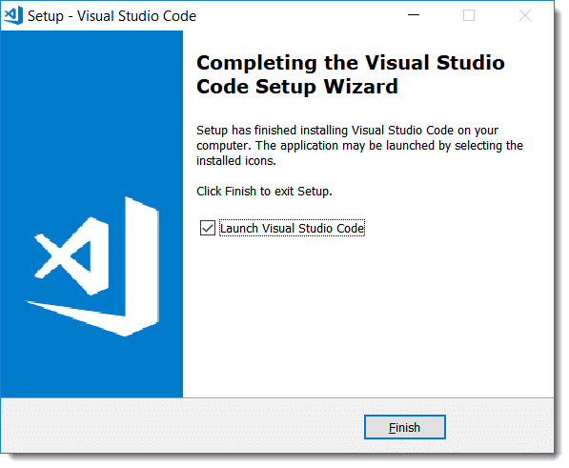

***8) Editor Screen Opens:***The VS Code IDE is launched and the editor is now open.

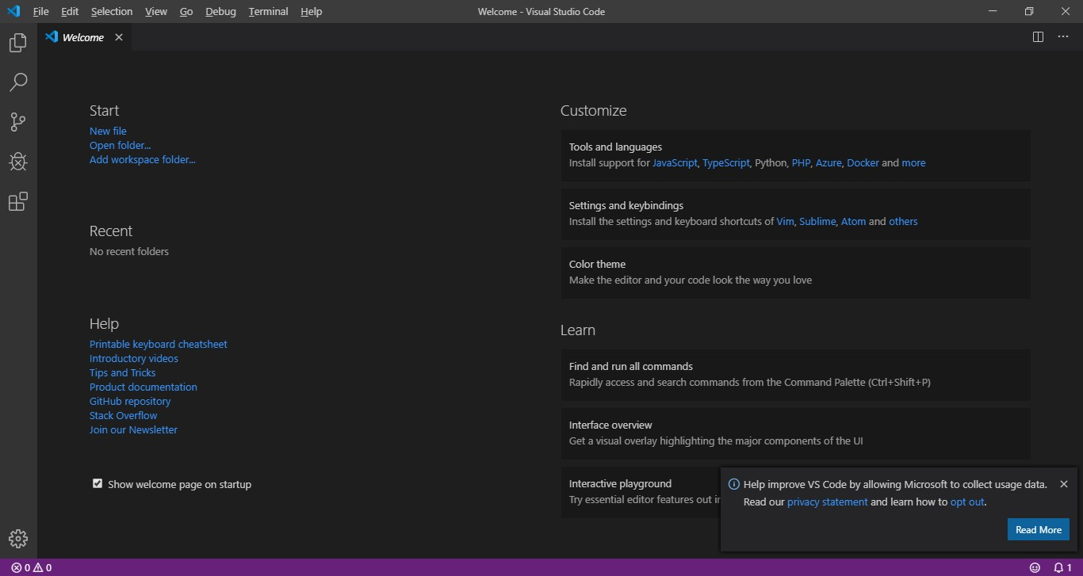

**Integrate Git Bash with Vscode: -**

## Steps to Install Git on Windows

1) Download the latest [***Git for Windows***](https://git-for-windows.github.io/).  
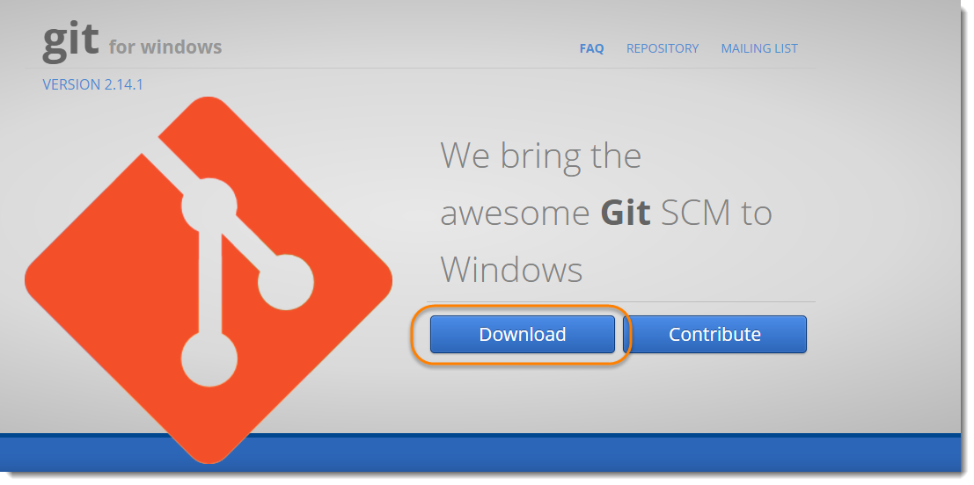

2) Go to the folder where new downloads gets store, at my machine by default folder is ***Download*** folder. ***Double click*** on the installer. The installer gets save on the machine as per the Windows OS configuration. My machine is ***64 bits***.  
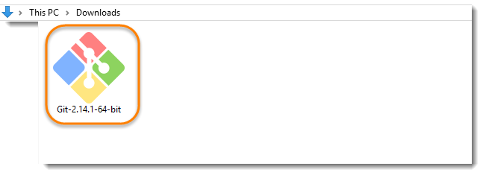***Note***: When you’ve successfully started the installer, you should see the Git Setup wizard screen. Follow the Next and Finish prompts to complete the installation. The default options are pretty sensible for most users.

***Note***: At the time of writing the tutorial on 9th Sep’17, the latest version is***Git-2.14.1.***

* 1. You may like to keep the installation to another folder, so here is the chance to do so I just want to keep it in the suggested default folder in my ***Program***

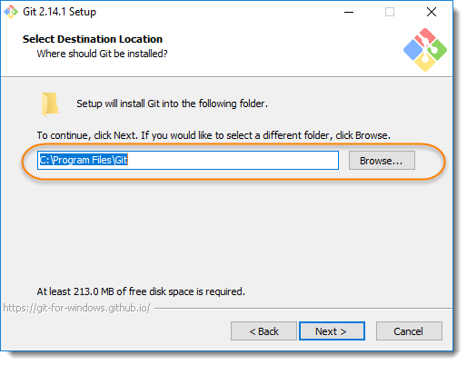

3) This is the option to store the shortcut of the Git under the ***Program Menu***.  
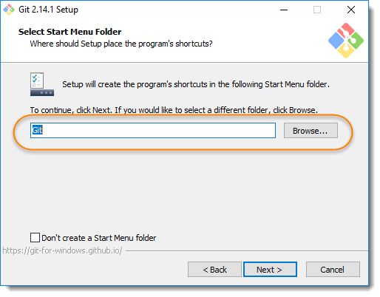

5) This is asking your choice that whether you like to Git from the ***Windows Command Prompt*** or you like to use some other program like ***Git Bash***. As of now just select the Windows Cmd for simplicity of the tutorial, later we will cover Git Bash and other as well.  
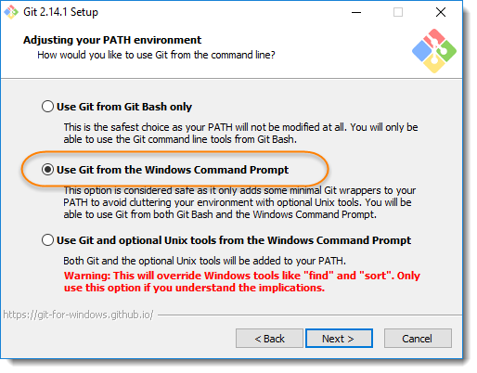

6) If you have PuTTY/TortoiseSVN installed, you may see this screen, otherwise just ignore this. Regardless, use ***OpenSSL*** to make things easy.   
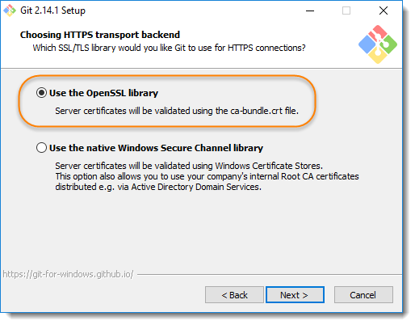

7) Here, we recommend to choose the option of ***Checkout Windows-style, commit Unix-style line endings***. Select next once you have done this.  
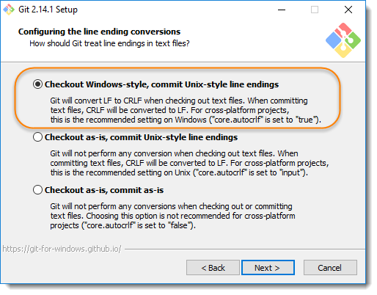

8) Again, just go with default selection and move forward.  
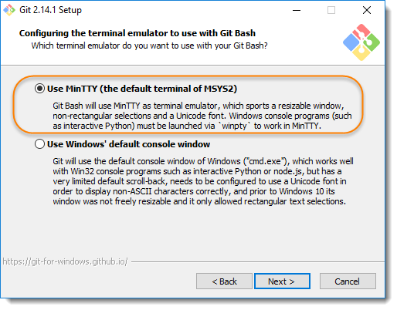

9) Just go with default selections, as we will cover the details in later advance chapter.  
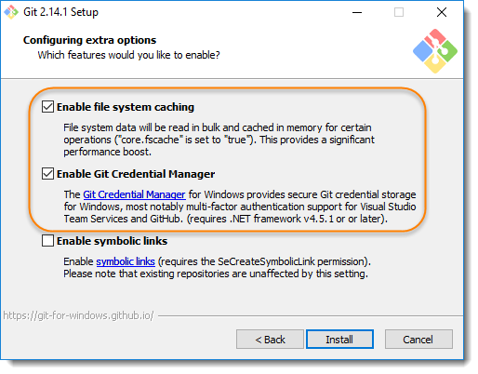

10) Now, its all done. This will just take few minutes to complete the installation as per your machine speed.  
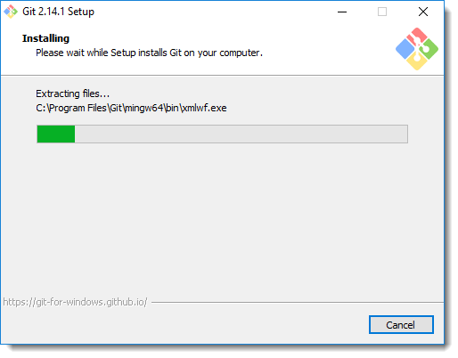

11) Once done, just click on Finish button.  
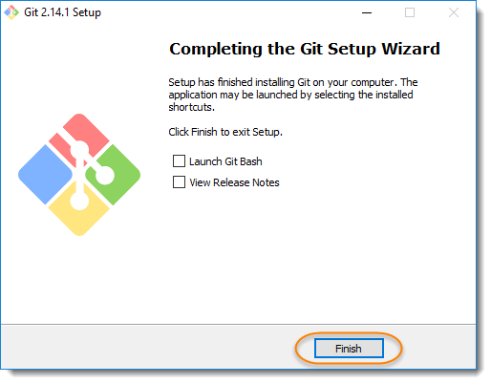

* Open Vscode click on File🡪Preferences🡪setting
* Click on top right {} brace

Paste the code “terminal.integrated.shell.windows": "C:\\Program Files\\Git\\bin\\bash.exe” **“**

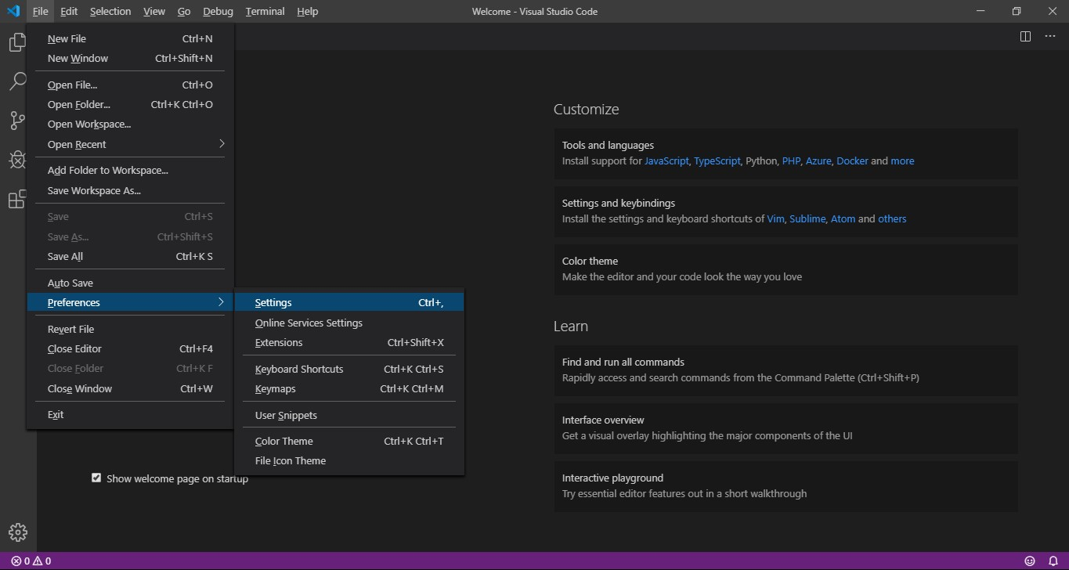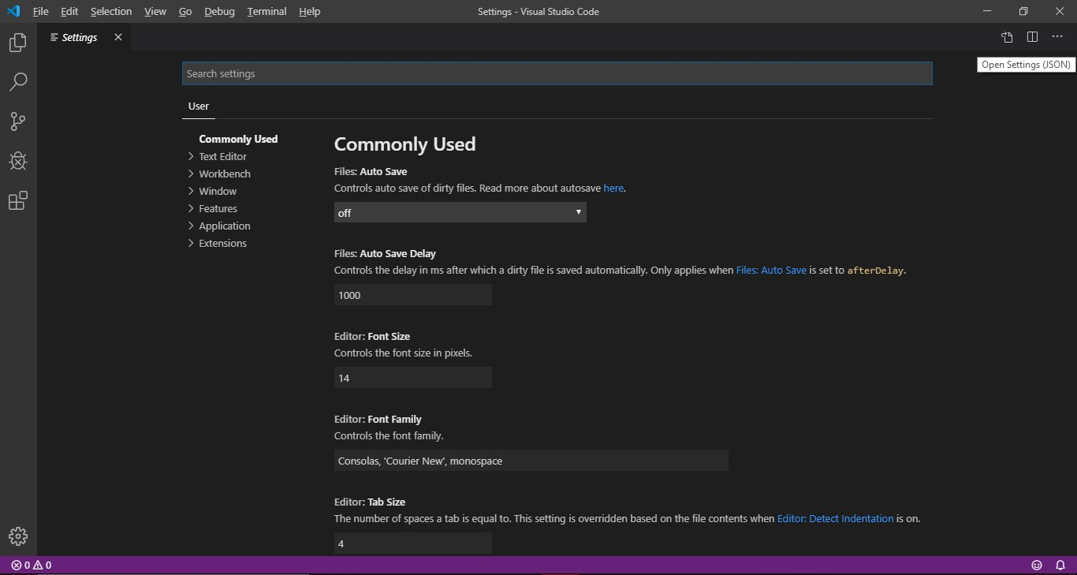

Click here

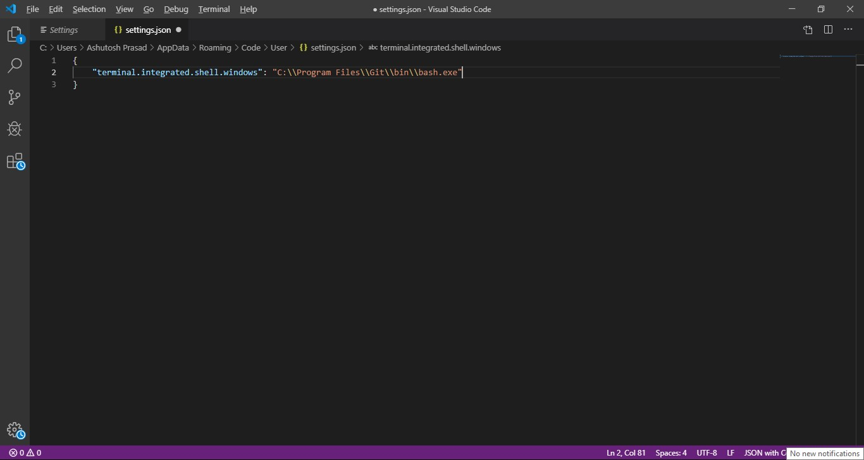

Save setting and reopen Vscode press”(ctrl+`)”.

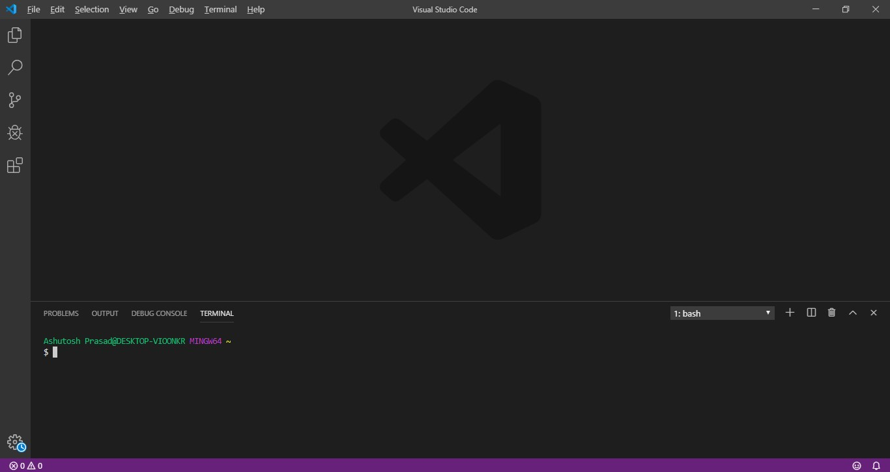

## Model

## What is Waterfall Model?

The ***Waterfall Model*** was the first Process Model to be introduced. It is very simple to understand and use. In a Waterfall model, each phase must be completed before the next phase can begin and there is no overlapping in the phases. Waterfall model is the earliest [***SDLC***](http://toolsqa.com/software-testing/software-development-life-cycle/)approach that was used for software development.

In “***The Waterfall***” approach, the whole process of software development is divided into separate phases. The outcome of one phase acts as the input for the next phase sequentially. This means that any phase in the development process begins only if the previous phase is complete. The waterfall model is a sequential design process in which progress is seen as flowing steadily downwards (like a waterfall) through the phases of ***Conception, Initiation, Analysis, Design, Construction, Testing, Production/Implementation and Maintenance.***

As the ***Waterfall Model*** illustrates the software development process in a linear sequential flow; hence it is also referred to as a ***Linear-Sequential Life Cycle Model***.

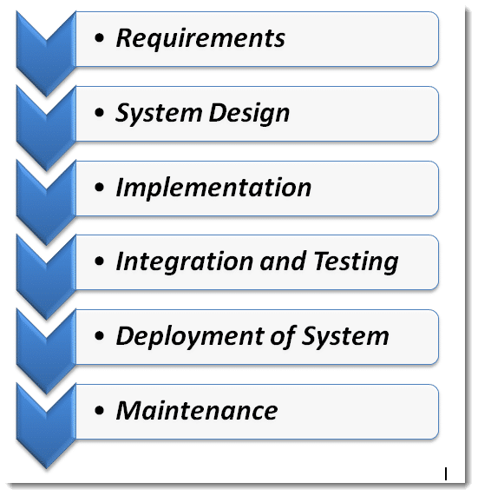

### **Sequential Phases in the Waterfall Model**

* **Requirements:**The first phase involves understanding what needs to design and what is its function, purpose, etc. Here, the specifications of the input and output or the final product are studied and marked.
* **System Design:** The requirement specifications from the first phase are studied in this phase and system design is prepared. System Design helps in specifying hardware and system requirements and also helps in defining overall system architecture. The software code to be written in the next stage is created now.
* **Implementation:** With inputs from system design, the system is first developed in small programs called units, which are integrated into the next phase. Each unit is developed and tested for its functionality which is referred to as Unit Testing.
* **Integration and Testing:** All the units developed in the implementation phase are integrated into a system after testing of each unit. The software designed, needs to go through constant software testing to find out if there are any flaw or errors. Testing is done so that the client does not face any problem during the installation of the software.
* **Deployment of System:** Once the functional and non-functional testing is done, the product is deployed in the customer environment or released into the market.
* **Maintenance:** This step occurs after installation, and involves making modifications to the system or an individual component to alter attributes or improve performance. These modifications arise either due to change requests initiated by the customer, or defects uncovered during live use of the system. The client is provided with regular maintenance and support for the developed software.

All these phases are cascaded to each other in which progress is seen as flowing steadily downwards (like a waterfall) through the phases. The next phase is started only after the defined set of goals are achieved for the previous phase and it is signed off, so the name “Waterfall Model “.

### **Advantages of the Waterfall Model**

* The advantage of waterfall development is that it allows for departmentalization and control. A schedule can be set with deadlines for each stage of development and a product can proceed through the development process model phases one by one.
* The waterfall model progresses through easily understandable and explainable phases and thus it is easy to use.
* It is easy to manage due to the rigidity of the model – each phase has specific deliverables and a review process.
* In this model, phases are processed and completed one at a time and they do not overlap. Waterfall model works well for smaller projects where requirements are very well understood.

### **Disadvantages of Waterfall Model**

* It is difficult to estimate time and cost for each phase of the development process.
* Once an application is in the testing stage, it is very difficult to go back and change something that was not well-thought out in the concept stage.
* Not a good model for complex and object-oriented projects.
* Not suitable for the projects where requirements are at a moderate to high risk of changing.

**Feasibility Study**

A Feasibility Study determines whether a project is worth doing. The process followed for making this determination is called a Feasibility Study. This type of study determines whether a project can and should proceed. Once it has been determined that a project is feasible, the analyst can proceed and prepare the project specifications that finalize the project specification.  
  
The following are the various types of feasibility studies that can be undertaken.

**Technical Feasibility:-**

This is concerned with specifying the equipment’s and the software to satisfy the user requirements. The technical needs of the system vary considerably but might include:

* The facility to produce outputs in a given time.
* Response time under certain conditions.
* Ability to process a certain volume of transactions at a specified speed.
* Facility to communicate data to a distant location.

Technical feasibility centers on the existing computer system, hardware, software etcetera and to what extent it can support the system. In examining the technical feasibility, the configuration of the system is given more importance than the actual hardware. The configuration should provide the complete picture of the system requirements, for example how many workstations are required and how these units are interconnected so that they would operate smoothly, etcetera. The result of the Technical Feasibility Study is the basis for the documents against which dealer and manufacturer can make bids. Specific hardware and software products can then be evaluated keeping in view the logical needs.

**Economic Feasibility: -**

Economic analysis is the most frequently used method for evaluating the effectiveness of a new system. More commonly known as cost/benefit analysis, the procedure is to determine the benefits and savings that are expected from a candidate system and compare them with costs. If benefits outweigh costs, then the decision is made to design and implement the system.  
  
It is not done to analyze the new system. Using a Gantt Chart schedule and part chart. We assumed that the benefit of the project is greater than the cost. So if we can develop the project easily then it is used for the evaluation of the proposed. We calculate the cost/benefit analysis and we assume that the benefit is feasible so we start developing the project. It is an analysis of the cost to be incurred in the system and benefits the derivable from the system. An economic Feasibility Study should demonstrate the net benefit of the proposed course of action in the context of direct and indirect benefits and costs to the organization and to the public as a whole. It should be required for both pilot and long-term activities, plans and projects.

**Operational Feasibility:-**

It determines how acceptable the software is within the organization. The evaluations must then determine the general attitude and skills. Such restriction of the job will be acceptable. To the users are enough to run the proposed budget, hence the system is supposed to the feasible regarding all except of feasibility. In operational feasibility, we attempt to ensure that every user can access the system easily. We develop a menu that users can easily access and we provide shortcut keys.  
  
We show a proper error message when any mistakes are made in the program. We provide help and a guideline menu to help the user.  
Changes in the ways individuals are organized into groups may then be necessary and the groups may now compete for economic resources with the needs of stabilized ones by converting a number in a file in software.

**Behavioral Feasibility:-**

Normal human psychology of human beings indicate that people are resistant to change and computers are known to facilitate change. Any project formulations should consider this factor also. Before the development of the Project titled "Delhi Metro", the need to study the feasibility of the successful execution of the project was felt and thus the following factors are considered for a Feasibility Study.

* Need Analysis.
* Provide the users information pertaining to the preceding requirement.

**Feasibility Study Report:-**

The result of the Feasibility Study provides us with the following facts:

* The automated system would increase the efficiency of the system.
* The automated system would increase customer's satisfaction.
* The automated system has many requirements such as Efficiency cost effectiveness, prompt service, Reliability.
* The automated system would add to the security features of the system
* The automated system should be simple to use, incorporate all necessary services and maintainable.
* This will cause some changes in the organization. These are:
* Change in staffing policies: present employees will need to be sent for training.
* New employees to be recruited will need to have the knowledge of the automated system.

**System Testing**

System Testing is the testing of a complete and fully integrated software product. Usually, software is only one element of a larger computer-based system. Ultimately, software is interfaced with other software/hardware systems. System Testing is actually a series of different tests whose sole purpose is to exercise the full computer-based system.

Two Category of Software Testing:-

* Black Box Testing
* White Box Testing

System test falls under the black box testing category of software testing.

White box testing is the testing of the internal workings or code of a software application. In contrast, black box or System Testing is the opposite. System test involves the external workings of the software from the user's perspective. System Testing involves testing the software code for following

* Testing the fully integrated applications including external peripherals in order to check how components interact with one another and with the system as a whole. This is also called End to End testing scenario.
* Verify thorough testing of every input in the application to check for desired outputs.
* Testing of the user's experience with the application.

That is a very basic description of what is involved in system testing. You need to build detailed test cases and test suites that test each aspect of the application as seen from the outside without looking at the actual source code.

**Software Testing Hierarchy:-**

As with almost any software engineering process, software testing has a prescribed order in which things should be done. The following is a list of software testing categories arranged in chronological order. These are the steps taken to fully test new software in preparation for marketing it:

* Unit testing - testing performed on each module or block of code during development. [Unit Testing](https://www.guru99.com/unit-testing-guide.html) is normally done by the programmer who writes the code.
* Integration testing - testing done before, during and after integration of a new module into the main software package. This involves testing of each individual code module. One piece of software can contain several modules which are often created by several different programmers. It is crucial to test each module's effect on the entire program model.
* System testing - testing done by a professional testing agent on the completed software product before it is introduced to the market.
* Acceptance testing - beta testing of the product done by the actual end users.

**OVERVIEW & REVIEW OF INPUT AND OUTPUT OF PROJECT**

**Screenshots: -**

GUI – Main display window with name of restaurant name current time and date with calculator

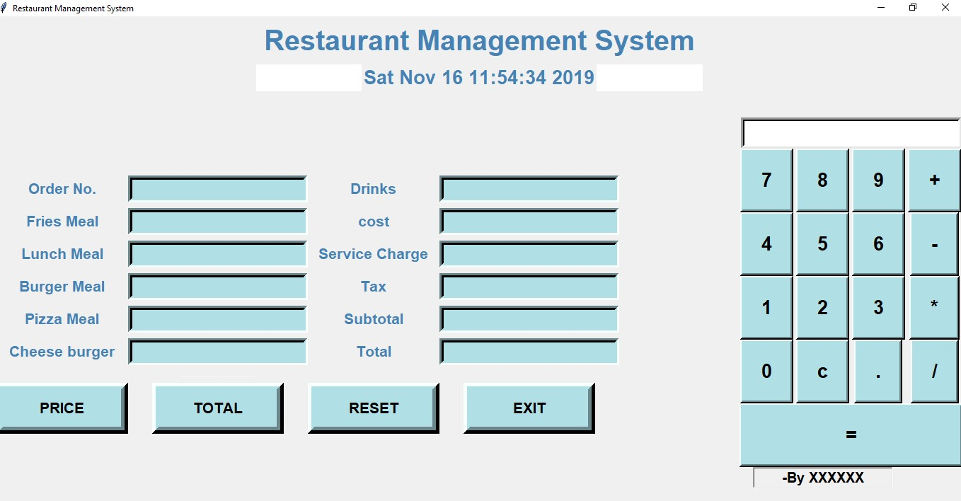

We have added a calculator for instant calculation –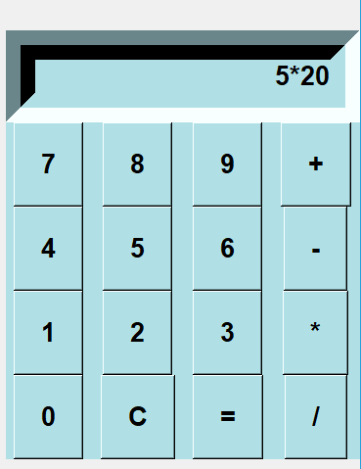 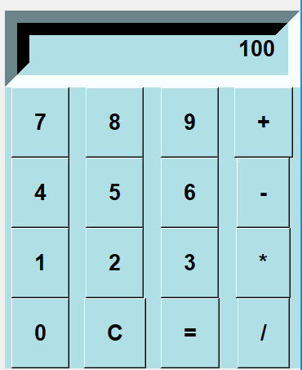Buttons –

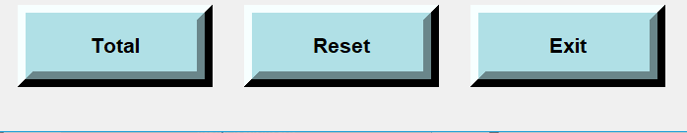

Exit button closes the window

Reset button resets all the values

Total button gives the calculation of Bill

**Input:**

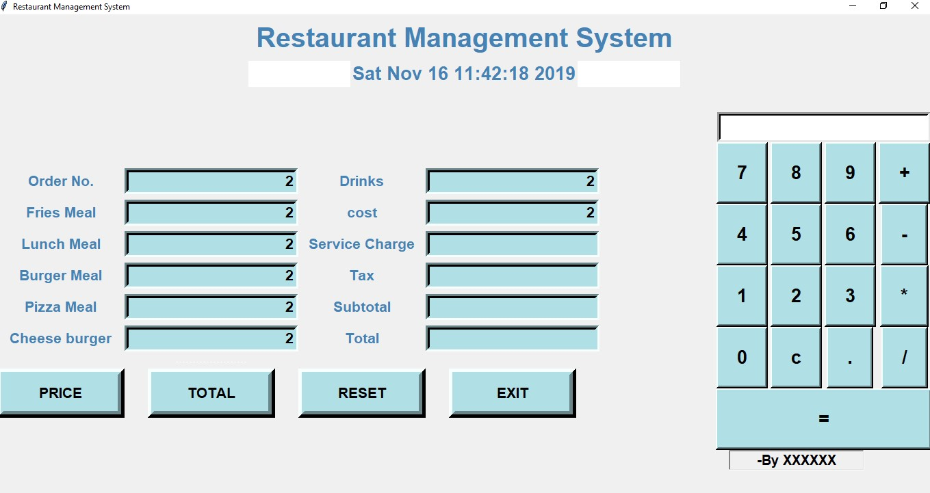

**Output: -**

